It’s time to start preparing for the 2014 AgrAbility National Training Workshop (NTW)! The NTW will be held in Lexington, Kentucky March 31-April 3. In previous years, our conference has been attended by up to 225 people representing 38 states, more than 30 of whom were farmers on scholarship. Additionally, we have had representatives from Canada, Sweden, and Brazil in attendance. These numbers represent records for the conference that we expect to continue to rise.

I would like to invite you to join us this year. We have set the exhibitor rate at $150 for one tabletop plus registration for your representative(s). The registration fee will be $350 for early registration (register before 3/7/14) or $400 for late registration. You can find more information on the conference website, http://workshop.agrability.org/2014/.

Being an exhibitor at the 2014 NTW will also allow you a short block of time in the AT Show and Tell session if you would like to talk about your products and give demonstrations or show videos of demonstrations.

We are also offering businesses the opportunity to be a sponsor of our event. Sponsorship would allow your company a complementary booth space and would also waive the registration fee for one representative. The minimum amount to reach this level is a donation of $800. Please see the attached sponsorship letter which details information on sponsorship levels and options.

Thank you for your time and consideration. Please do not hesitate to contact me with any questions at the number listed below or by email. Thanks again and I hope to see in Lexington this spring!

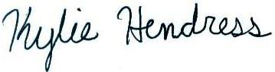

Kylie Hendress
Engagement Coordinator
National AgrAbility Project
Purdue University
225 S University Street
West Lafayette, IN 47907
765-494-6679
www.agrability.org
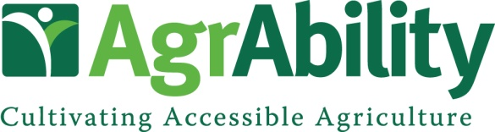

National Training Workshop
Lexington, KY March 31-April 3, 2014

Vendor Contact Information

Company Name:
Contact:
Address:
City:
State/Province: Zip Code:
Phone: Fax:
Email: Website:
Are you interested in helping sponsor this event? Please see the benefits of sponsorship below and let us know if you would like to take advantage of this opportunity. Thank you!

Benefits to Sponsor

- Complementary booth space at the NTW trade show (for sponsorships of $800 and above)
- Complementary registration for one company representative (for sponsorships of $800 and above)
- Signage and verbal recognition throughout the National Training Workshop
- Company name and logo on NTW schedules and programs
- Company logo displayed on the AgrAbility NTW website with a link to the company’s website
- Company listed as a sponsor on promotional materials which will be distributed nationwide

Suggested Sponsorship Opportunities

Bronze Level: Under $1000
Hospitality Room: $800
Promotional Giveaways: $1,000
Speaker Gifts: $1,000

Silver Level: $1001-$3000
Pre-Conference Tour: $1,500
Morning Break: $1,500
Afternoon Break: $2,500
Gold Level: $3001-$5000
Conference Tour: $3,100
Breakfast: $3,500
Welcome Reception: $4,000

Platinum Level: Over $5000
Keynote Speaker: $5,000
Lunch: $5,500
Banquet/Benefit Auction: $10,000

We would be glad to discuss other options to customize your sponsorship. Please call or email.
All donations are tax deductible and are administered by the National AgrAbility Project at Purdue University. Checks should be made payable to Purdue University. Mail to Breaking New Ground Resource Center, Purdue University, 225 South University St, West Lafayette, IN 47907.

